Environmental Science
Course Disclosure
2019-2020
Canyon View High School

Teacher: Mr. Pollock 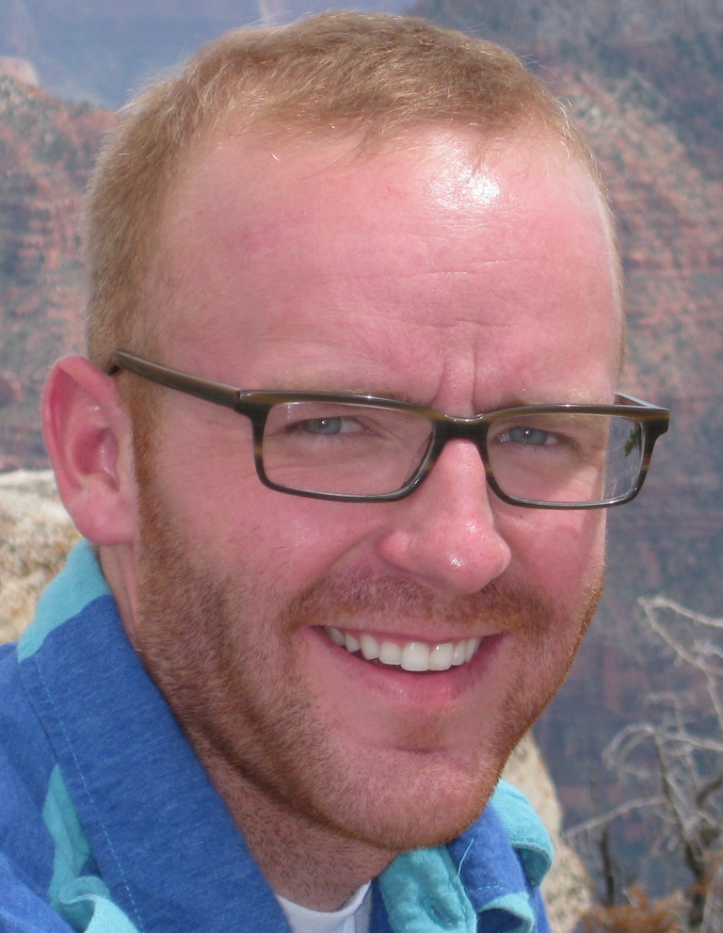
Email: steven.pollock@ironmail.org
Website: www.pollockscience.weebly.com
Course Description
Science is a way of knowing, a process for gaining knowledge and understanding of the natural world. The Science Core Curriculum places emphasis on understanding and using skills. Students should be active learners. It is not enough for students to read about science; they must do science. They should observe, inquire, question, formulate and test hypotheses, analyze data, report, and evaluate findings. The students, as scientists, should have hands-on, active experiences throughout the instruction of the science curriculum.
For more information please visit: http://www.uen.org/core/core.do?courseNum=3520
Class Rules Required Class Materials
- Be Respectful Personal Binder 1” not to be kept in class.
- Be Prepared
- Be on time Pen/Pencil- (no red ink)
- Be involved Colored Pencils – recommended but optional
- Have fun!!
- Other rules pertaining to handbook i.e. cellphones/electronic devices/dress code http://cvhs.ironk12.org/2014-2015Handbook.pdf
Class Website
www.pollockscience.weebly.com is the go to spot to see a breakdown of everyday play by play. You can also reach this from the faculty page for CVHS by clicking on my name. If a student misses class…they are expected to go to this website first! Each day will be descriptive of what we did, what’s due, what’s homework …for each day. Science Lab: This IS NOT a lab based class however many activities that will be done throughout the year. A lab safety contract will be mandatory for the purpose of us using the lab. Rule #1-follow instructions. No horseplay or roughhousing in the lab. Inappropriate behavior cannot be tolerated in a lab setting. Safety first!

CITIZENSHIP- It is expected that your child will come prepared everyday. Citizenship grade will be determined by: attendance, tardiness, academic performance and adherence to rules/behavior. Review the rubric at CVHS website. This will also be tied to academic grade in correlation with ICSD’s essential 8.
GRADING POLICY/SCALE
- Letter grades are shown as percentages of total points possible.
A = 93 - 100 % C+ = 77 - 79% D- = 60 - 62%
A- = 90 - 92 % C = 73 - 76% F = 59 – 0%
B+ = 87 - 89% C- = 70 - 72%
B = 83 - 86% D+ = 67 - 69%
B- = 80 - 82% D = 63 - 66%
- Students will be graded both by completion of assignments and the quality of submitted work.
- Extra-Credit is a privilege that can be taken away. Phones will be taken away/returned after class when causing distraction, also resulting in loss of extra credit privileges.
- Permission is granted to watch G, PG, and PG-13 videos/ material as they relate to the Utah State Core Standards. Let me know otherwise.

MAKE-UP WORK AND LATE WORK
- Unexcused absences: Make-up work will not be given! This is a school wide policy!
- Excused absences: Students are responsible to pick up their own make-up work. This work will be due the following class period upon returning to school.
- Assignments turned in after the due date, are considered late. Late work will be accepted for up to one week, but only for half credit.
- No Late work or make-up work will be accepted the last week of each quarter.
- School excused absences are considered the same as an excused absence. You are still responsible for the missed work. You know when you will be absent and must talk to me in advance.

CHEATING
Simply put…cheating of any kind will not be tolerated and will result in a “ZERO” and the citizenship grade will be UNSATISFACTORY!
Text Book
A textbook can be provided for home if the student so chooses? It will have a number and must be returned.
Failure to return will result in a fee equal to the worth of the book
DRSL’s (Desired Results for student Learning) 1. Competent Learner, 2. Effective Communicator, 3. Responsible Citizen
Canyon View High School does not discriminate on the basis of race, color, national origin, sex, religion, or qualified disability.
Canyon View High School no discarimina a raza, color, nacionalidad, genero, or habilidad diferenciad

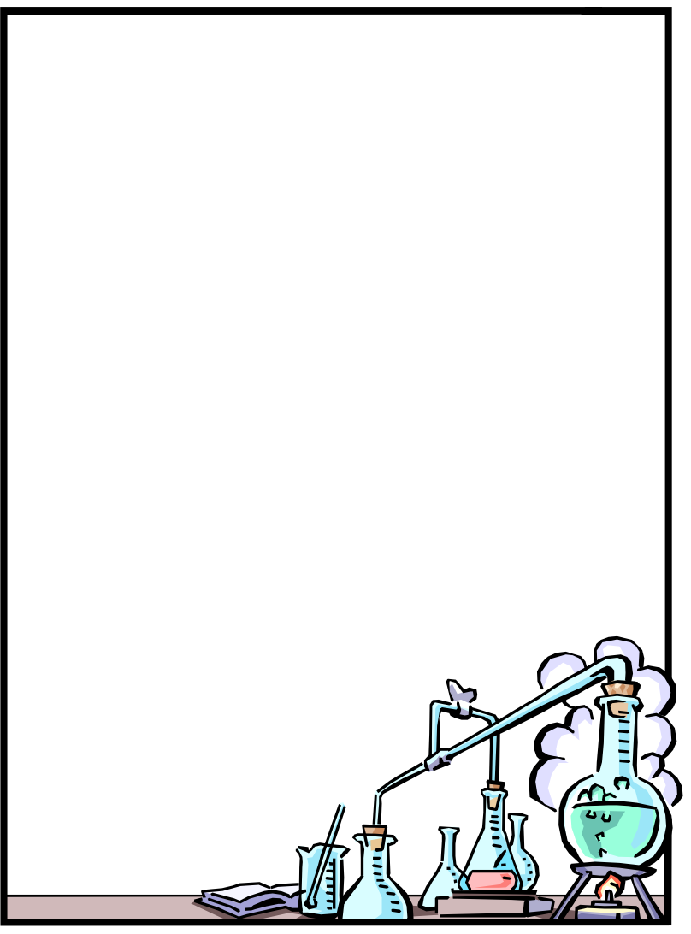

Environmental Science
COURSE DISCLOSURE
Mr. Pollock
2019-2020

Parents, please review this disclosure with your student. The bottom needs to be signed indicating that you and your student have read, understand, and agree to this document, and will be held responsible for the content herein. This is the first graded assignment this quarter, so please return it signed ASAP! If there are any questions or concerns, please feel free to email or call our class. Thank you very much!!

Mr. Pollock
CVHS Science
www.pollockscience.weebly.com

Students First & Last Name
(PRINT)________________________________________
(Signature)_____________________________________

Date________________ Class Period ________________

Parents Signature
_______________________________ Date ____________

***Turn in by the first Friday,
for 25 points!!!***

